Data Analysis Report[Global Superstore Data]

objective
This project aims to analyze the Global Superstore dataset to simulate retail sales across various regions, identify the product category with the highest profit margin, and determine the top-performing regions.
Data Cleaning:
In this step, we examined the dataset to identify and resolve any issues such as missing or NaN values, inappropriate data types, and unnecessary columns. The process involved the following:
- Missing Values Check:
We began by checking for missing, null, or empty values in the dataset. Fortunately, no such issues were found.
- Data Type Validation:
We then verified whether all columns had appropriate data types using df.dtypes. We found that the Order Date and Ship Date columns were stored as strings, so we converted them to datetime format using the following commands:
>>>df['Order Date'] = pd.to_datetime(df['Order Date'])
This line converts the "Order Date" column in the DataFrame df from string (or object) format to datetime format using pandas.to_datetime(). This conversion allows for date-based operations, such as filtering by year, extracting month, or calculating durations.
>>>df['Ship Date'] = pd.to_datetime(df['Ship Date'])
Similarly, this line converts the "Ship Date" column to datetime format. Once in datetime format, you can perform calculations like shipping time, compare dates, and plot time-series trends.
- Dropping Unnecessary Columns:
Finally, we removed the Customer ID and Customer Name columns as they were not relevant to the insights we aimed to derive from the analysis.

EDA[Exploratory Data Analysis]:
In this step, we took a deeper look of a data, digging bit more using commands like df.head(), df.tail(), df.shape, df.describe and groupby. Here is how we did this step:
- Firstly we started with taking a overall look of the data using commads:
>>df.head(): to print first 6 values.
>>df.tail(): to print last 6 values.
>>df.shape: to print the shape of the dataset.
>>df.describe(include=’object’)
>>df.info()
- Then we began digging bit deeper into it using groupby command and exracting the informations so as to understand diffrerent trends, and dependencies of the features, the commands we used in this step are:
>>>print(df.groupby("Region")['Sales'].mean().sort_values())
This line groups the DataFrame df by the "Region" column, calculates the mean sales for each region, and then sorts the regions by their average sales in ascending order. This helps to identify which region has the lowest to highest average sales.
>>>print(df.groupby("State")["Profit"].mean().sort_values(ascending=True))
This command groups the data by "State", computes the average profit per state, and sorts them in ascending order. It's useful for seeing which states are least to most profitable on average.
>>>print(df.groupby("Category")["Profit"].mean().sort_values(ascending=True))
This line groups the data by "Category", calculates the mean profit for each category (like Furniture, Technology, Office Supplies), and sorts them in ascending order. It helps understand which product categories are less or more profitable on average.
>>>print(df.groupby("Sub-Category")["Profit"].mean().sort_values(ascending=True))
Here, the data is grouped by "Sub-Category", and the average profit is computed for each sub-category (e.g., Binders, Phones, Chairs). Then, it is sorted in ascending order to reveal which sub-categories yield low or high average profits.
>>>print(df.groupby("Segment")["Sales"].sum().sort_values())
This command groups the dataset by "Segment" (e.g., Consumer, Corporate, Home Office), sums up the total sales in each segment, and then sorts them. It allows us to identify which customer segments contribute least or most to the total sales.
TIME BASED RESAMPLING:
Next, we moved on to the step of time-based resampling. This technique in time series analysis involves changing the frequency of observations — for example, by aggregating or interpolating data over specific time intervals such as daily, monthly, or yearly.
Given the large size of our dataset, we thought it would be more meaningful and manageable to analyze the data on a monthly basis. This approach would help us uncover important patterns and trends more effectively. That’s when the idea struck — if we break the data down month by month, we’ll be able to extract valuable insights more clearly.
To achieve this, we used the resample function.
>>>M = df['Sales'].resample("ME").sum()
This command allowed us to calculate monthly sales by summing the sales values over each 30-day period and storing them in a series.
After computing the monthly sales, I chose to visualize the results using a line plot. This helped reveal that sales peaked in July 2016. Below is the resulting plot:
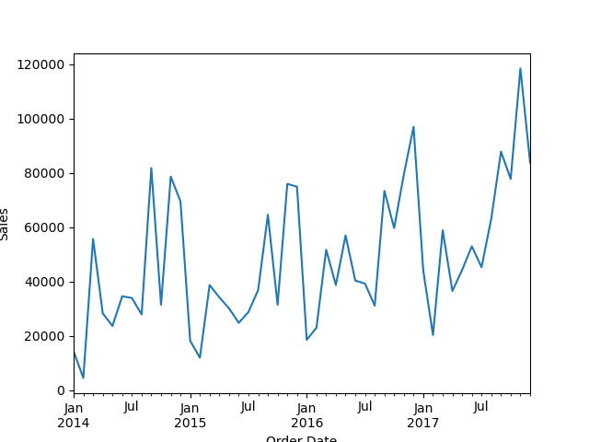

FEATURE ENGINEERIG:
The next crucial step in our process was feature engineering. This involves identifying and handling outliers in relevant features and creating new features within the dataset to extract deeper and more meaningful insights.
Here’s how we approached feature engineering:
- We began by checking for outliers in the ‘Sales’ feature. For this, we used a boxplot, as it’s one of the most effective and widely used methods to detect outliers in numerical data.
>>>sns.boxplot(x=df["Sales"])
This command generates a boxplot for the “Sales” column using the Seaborn library, helping us visually identify any unusually high or low values that deviate significantly from the rest of the data.
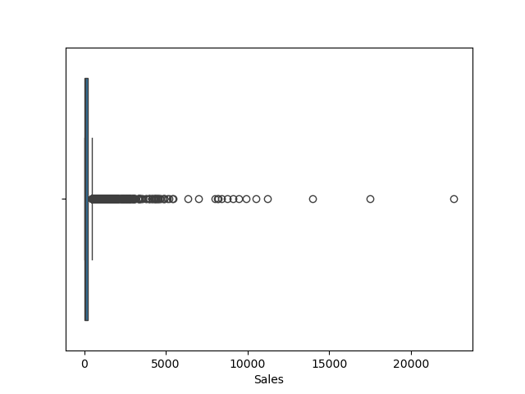
From the boxplot, we observed that most of the values lie outside the box, forming a long tail, which clearly indicates that the sales data is highly skewed. The values far from the central range are considered outliers. Additionally, we noticed that the dataset contains many repeated values and lacks variability, especially when analyzed across different states — showing very little variation in sales figures from one state to another.
- To take our analysis a step further, we moved on to creating new features:
Since one of our goals was to determine which category has the highest profit margin, we realized we first needed a new column — ‘Profit margin’. This feature was calculated using a straightforward formula:
profit margin = profit / sales
Here’s the command we used:
>>>df['Profit margin'] = df['Profit'] / df['Sales']
The next feature we introduced was the ‘Profit flag’. This column stores boolean values to indicate whether a particular transaction resulted in profit or loss. A value of True represents a profit, while False indicates a loss. We created this feature using a lambda function with a conditional expression:
>>>df['Profit flag'] = df['Profit'].apply(lambda x: True if x > 0 else False)
The lambda function helped us quickly and efficiently implement the condition inline, making the feature creation clean and concise.

DATA VISUALIZATION:
Our next step is data visualization, which will going to give us a better insight of the data, and with this step we are going to get a enhaced view of the dataset and most of our answeres.
Since, we have to find which category has largest profit margin so plotting a ‘category vs Total sales’ bar chart will be a best decision, which will depict a category wise sales and profit.
Here’s the plot: 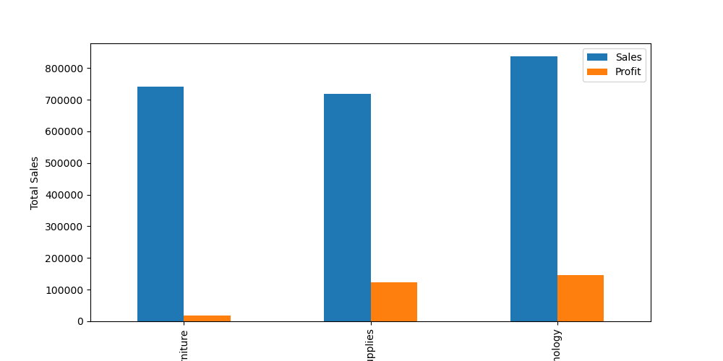
The code block is:
>>>category_data=df.groupby('Category')[['Sales','Profit']].sum()
>>>category_data.plot(kind='bar',figsize=(10,5))
>>>plt.ylabel('Total Sales')
>>>plt.savefig("sample_plot.png")
>>>plt.show()
We first grouped the ‘category’ as all the unique values will be together like all the furniture’s sales and profit will be sum and stored into a new dataframe named category_data, then plot it using a bar plot.
Insight we got from there is, “Technology” sector has the largest sales, profit and profit per sales.
Since we have found ‘monthly_sales’, so plotting it using a line plot will give us a ‘Sales ove the time’ plot and for a store owner it is a very crucial insight, with this plot he will be able to know the time when the sales was low and can find what can be factors due to which the sales were low and acknowledge them in a better way to enhace his sales. Here’s the plot:
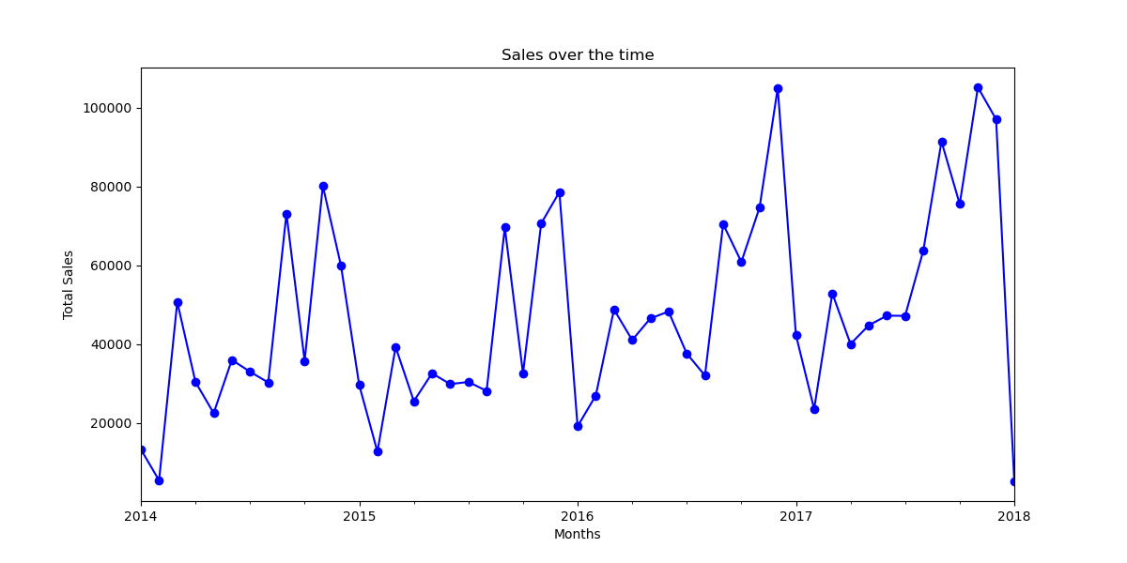
Code block:
plt.close('all')
plt.figure(figsize=(12,6))
df['Ship Date']=pd.to_datetime(df['Ship Date'])
monthly_sales= df.groupby(df['Ship Date'].dt.to_period('M'))['Sales'].sum()
monthly_sales.plot(kind="line",marker='o',color='b')
plt.xlabel('Months')
plt.ylabel('Total Sales')
plt.title("Sales over the time")
plt.savefig("sample_plot2.png")
plt.grid(True)
plt.show()
Explaination and logic:
This code generates a line plot showing total sales over time. It first closes any existing plots and creates a new figure with a specified size. The 'Ship Date' column is converted to datetime format to enable time-based grouping. Sales are then grouped by month using .dt.to_period('M') and summed. The resulting monthly sales data is plotted as a blue line chart with markers. Axis labels and a title are added, the plot is saved as an image (sample_plot2.png), and grid lines are enabled for clarity before displaying the final chart.

Analysis:
we can clearly see the our sales was very fluctuating and after 2017 there was a very steep downfall but in 2018 specifically our sales gone to the lowest.

Here are some basic plots :
We plotted some of the esseential but not required plots:
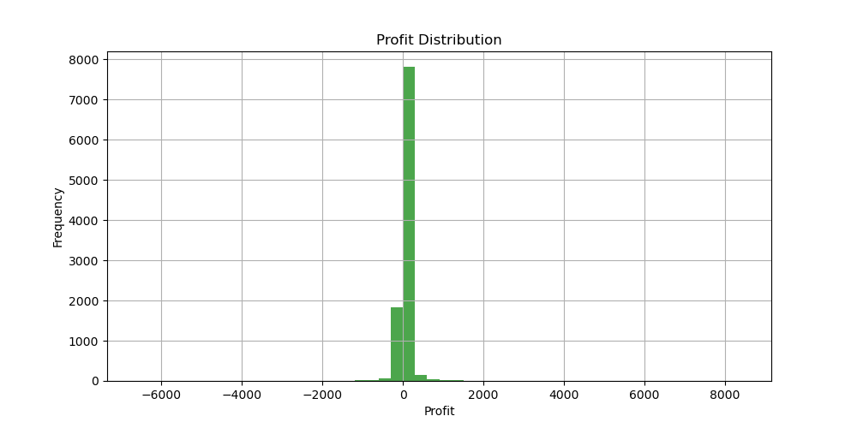
This plot shoes the Profit distribution of this dataset.
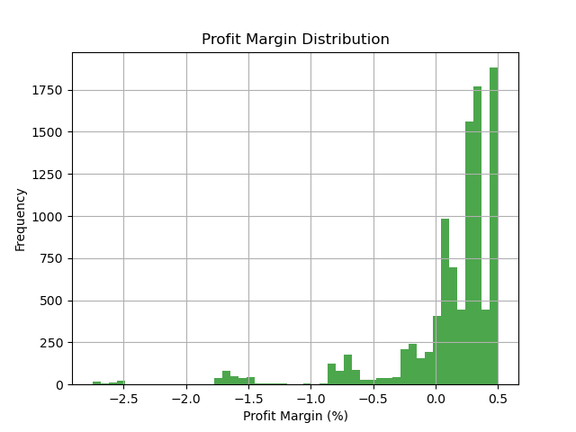
This plot depicts that we have a good frequency on our products having more profit margin.
Next, as part of our task to explore potential correlations, we analyzed the relationship between ‘Sales’ and ‘Profit’. To do this, we chose to use a scatter plot. The reason behind selecting a scatter plot is that it not only shows whether a relationship exists but also provides a rough idea of the data distribution and clusters. In contrast, a heatmap would only indicate the degree of correlation without giving any insight into the spread or density of individual data points.
Here’s the code we used:
sns.scatterplot(x=df['Sales'], y=df['Profit'], alpha=0.5)
plt.xlabel("Sales")
plt.ylabel("Profit")
plt.title("Sales vs Profit Relationship")
plt.grid(True)
plt.savefig("sample_plot3.png")
plt.show()
Explanation and Logic:
This code generates a scatter plot to visualize the relationship between sales (x-axis) and profit (y-axis). The parameter alpha=0.5 makes the data points semi-transparent, which helps in spotting dense clusters where points overlap. Axis labels and a descriptive title were added for clarity, and grid lines were enabled to make interpretation easier. The plot was also saved as an image (sample_plot3.png) before displaying it with plt.show().
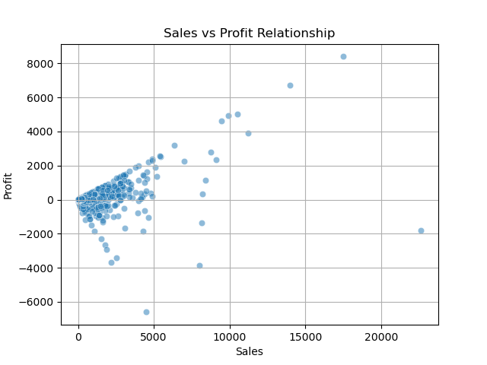
Analysis:
From the scatter plot, we observed that sales and profit appear to be highly correlated. Since this is business data, the dense clusters likely represent common transaction behaviors, such as frequent discounting patterns that result in similar profit outcomes.

FINAL ANALYSIS:
Here are my detailed insights, summarized point by point:
- The analysis reveals a strong positive correlation between Profit and Sales. A consistently high profit margin suggests robust business performance, with many products being sold at favorable prices. However, there are also instances of negative margins, indicating that certain products were sold at a loss.
- Examining sales trends over time, we observed significant fluctuations. Sales maintained a steady upward trajectory until late 2017, after which there was a sharp decline. Notably, the early months of 2018 mark the lowest sales period in the dataset.
- Among all product categories, the Technology segment clearly outperforms, delivering the highest profit margin compared to the other two categories.
- The United States emerged as the top-performing country, contributing the most to overall sales and profits.
- West is the top performing region.

Answers to the Questions asked:
- Which category has the highest profit margin?
Ans) ‘Technolog’ have the highest profit margin.
- What regions perform best?
Ans) ‘West’ performed the best.

